Screenshoot Hasil Program API Aplikasi Inventaris

-Laveda Nafis Arshanda-

1. API Login

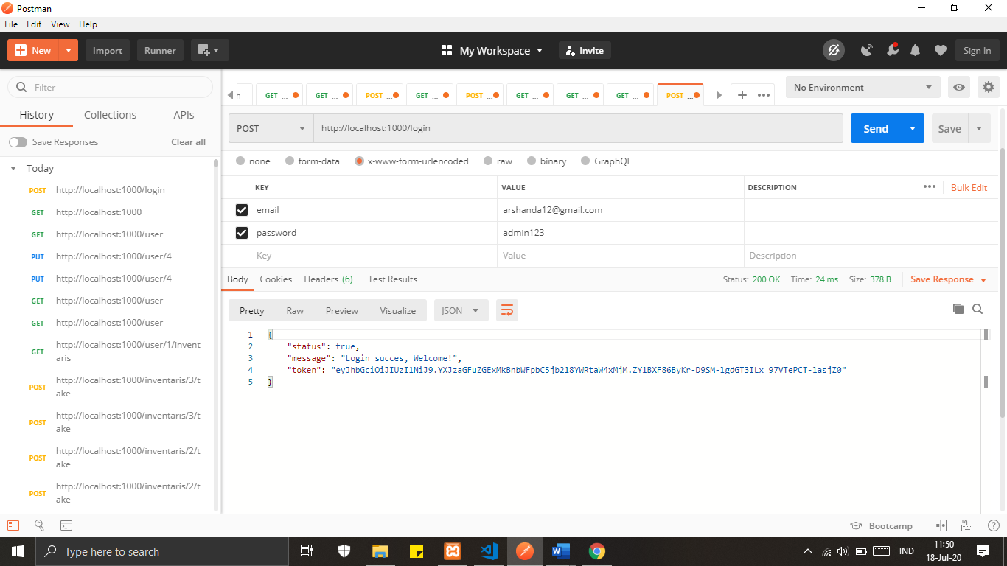

1. API Get Profil

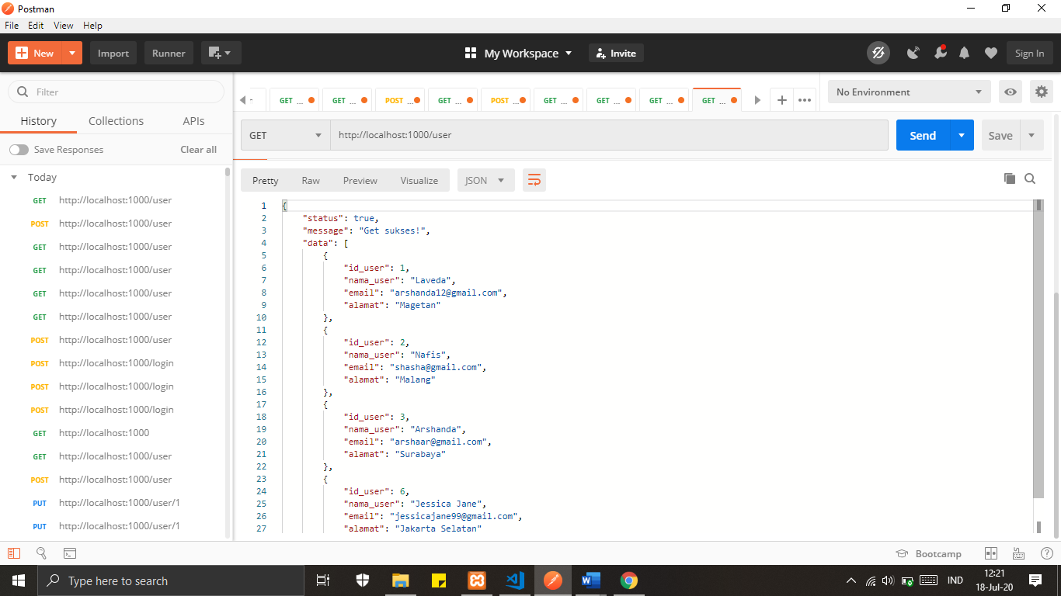

1. API Update Profile

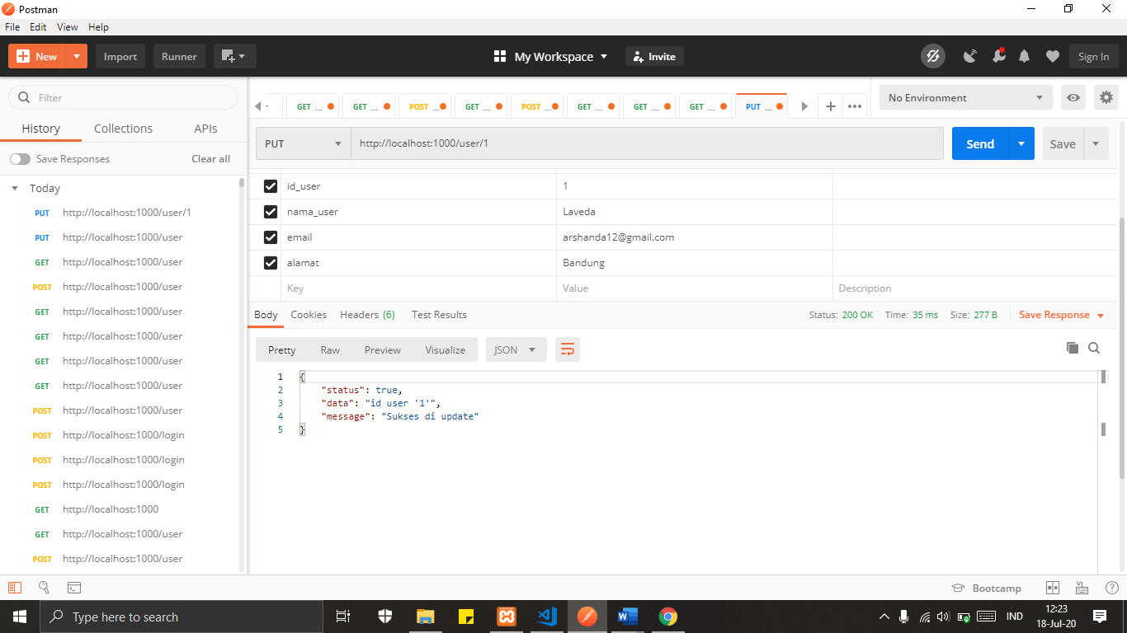

1. API Tambah Inventaris

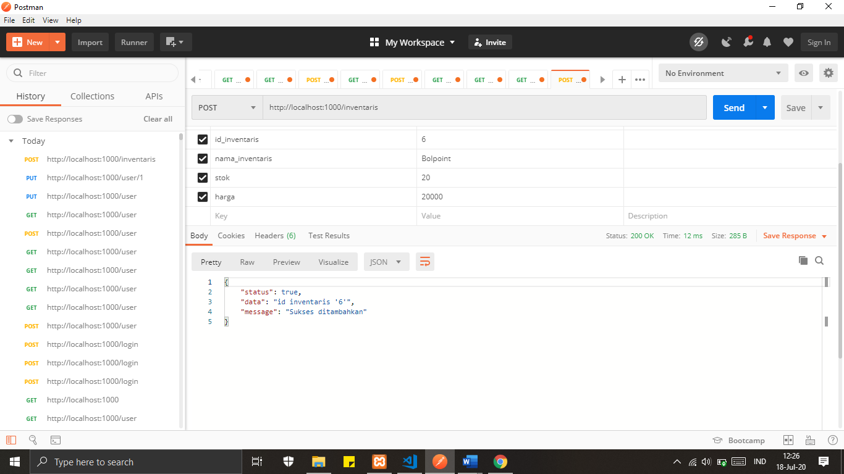

1. API Update Inventaris

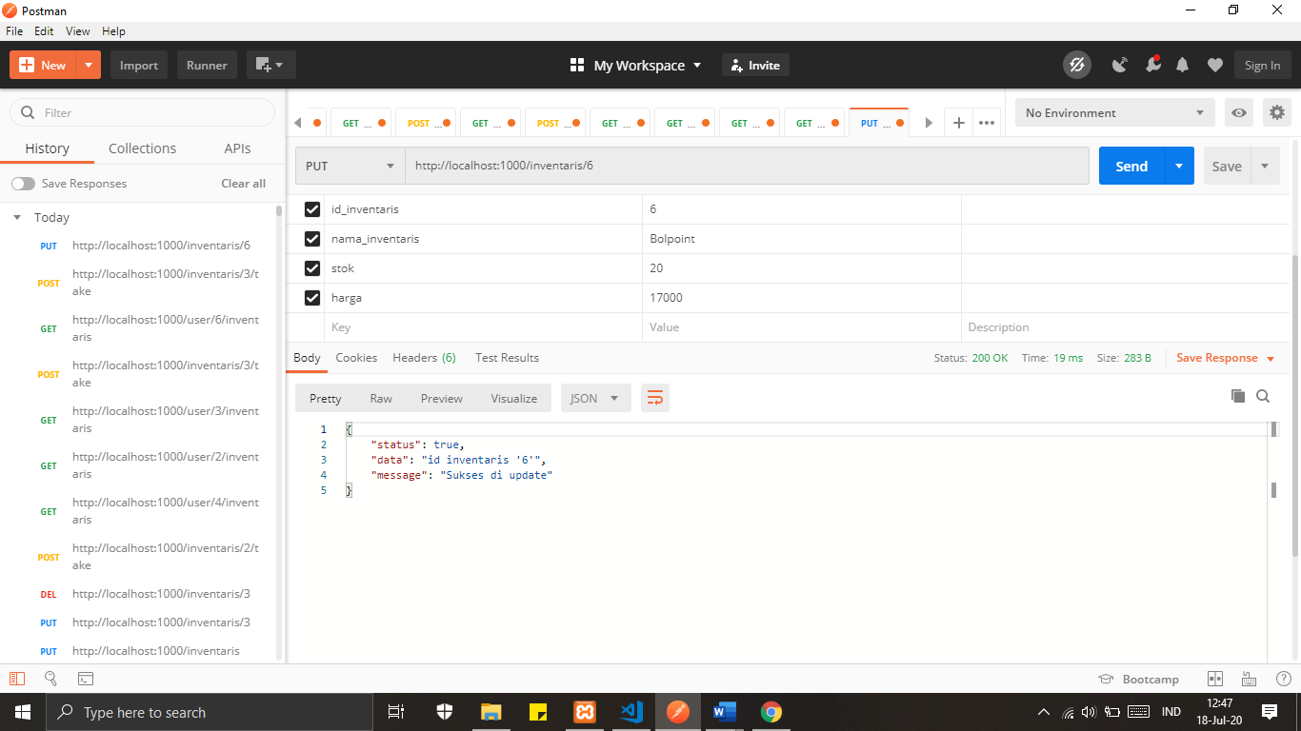

1. API Hapus Inventaris

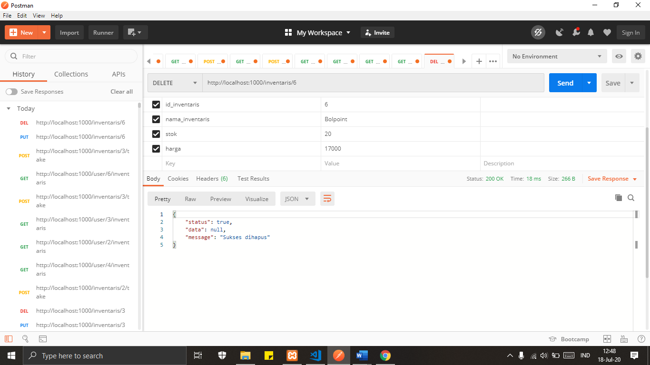

1. API List Inventaris

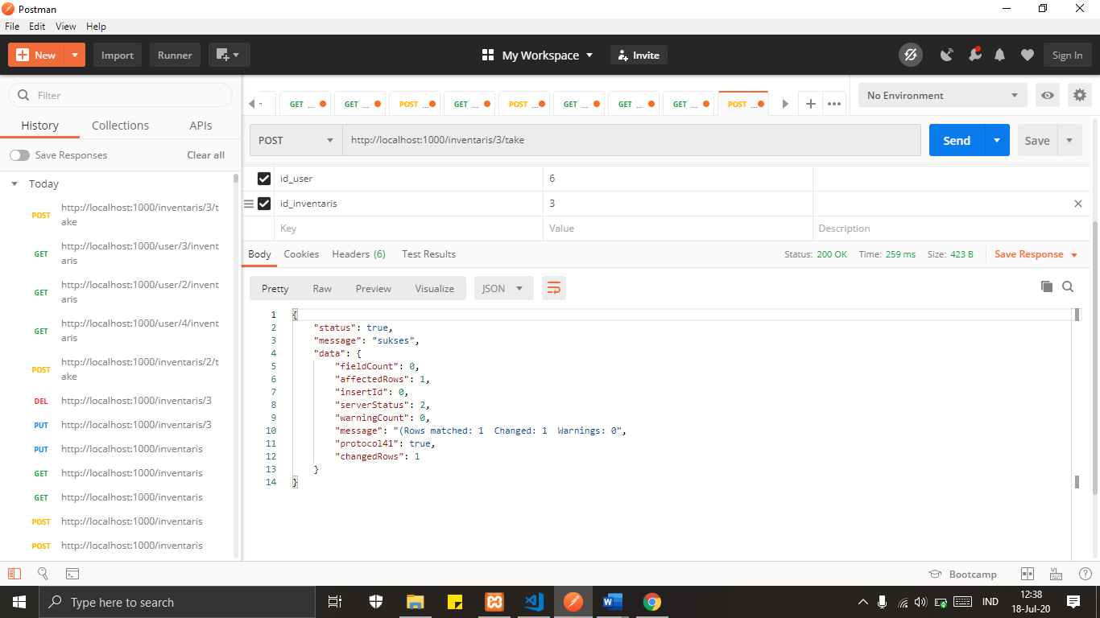

1. API Inventaris By Id

